Ve370 Introduction to Computer Organization
Homework 1

- Exercise 1.3.1 ~ 1.3.3 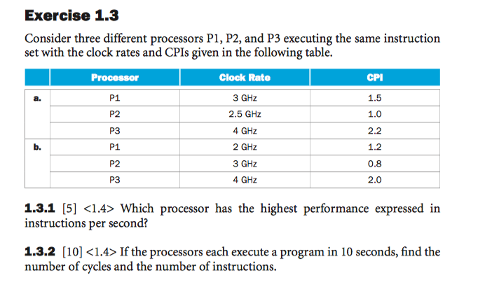
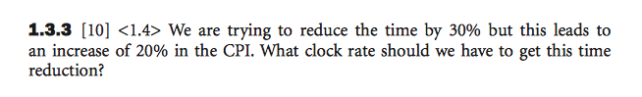
- Exercise 1.4.4 ~ 1.4.6
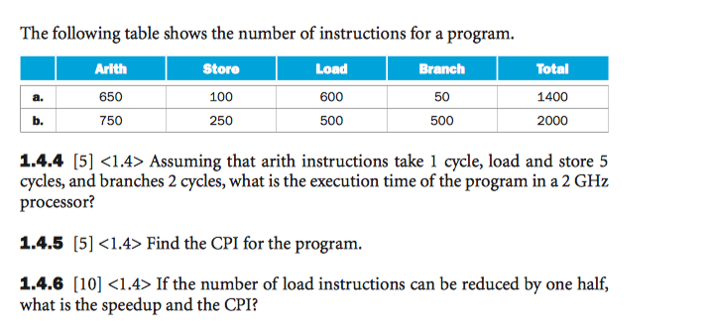
- Exercise 1.10.1 ~ 1.10.5
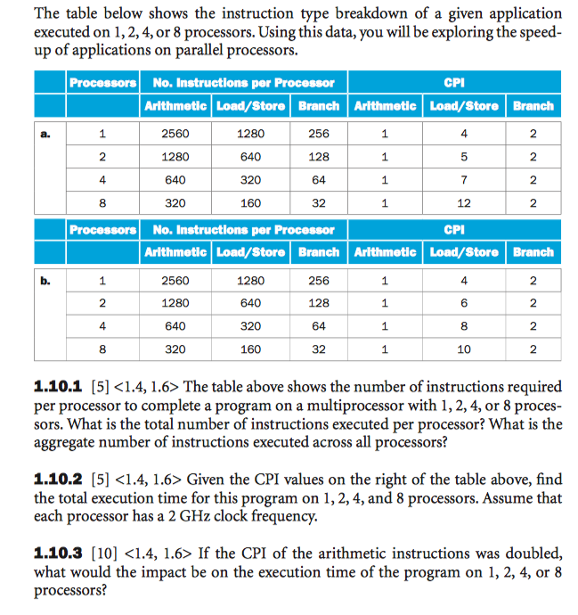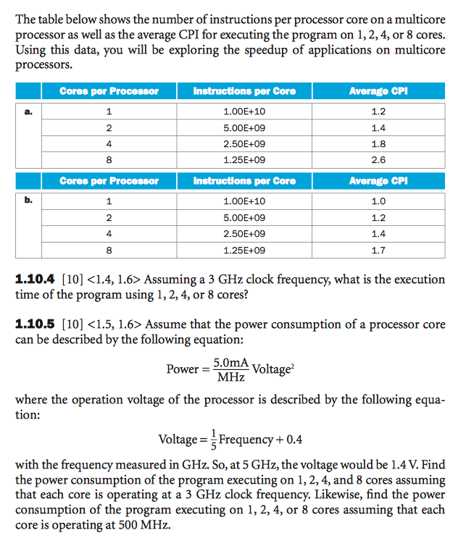
- Exercise 2.3.1
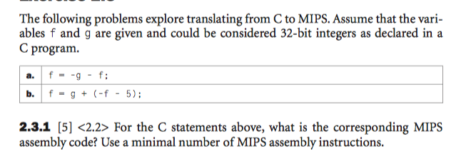
- Exercise 2.6.1
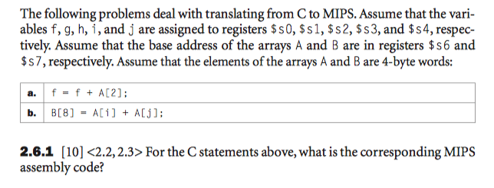
- Exercise 2.6.4
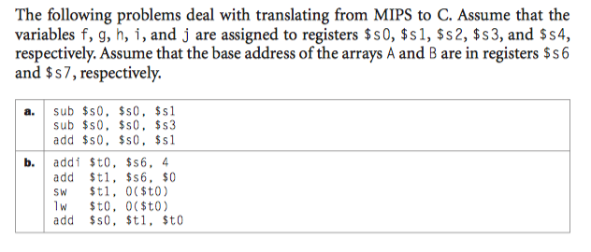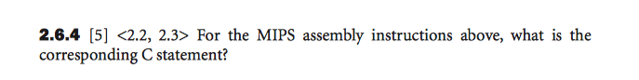
- Convert the following assembly code fragment into machine code, assuming the memory location of the first instruction is 0x10000400: (15 points)
LOOP: slt $t2, $zero, $t0
bne $t2, $zero, ELSE
j DONE
ELSE: addi $s2, $s2, 2
addiu $t0, $t0, 1
j LOOP
DONE: …
- Following memory location has address 0x10000000 and content 0x15478933.
 | 0 | 1 | 2 | 3
0x10000000 | 15 | 47 | 89 | 33
Write MIPS assembly instructions to load the byte 89 to register $s1, then show the content of $s1 after the operations. (5 points)
- Exercise 2.19.1 (15 points)
- Exercise 2.19.2 (10 points)
- Exercise 2.19.3 (10 points)
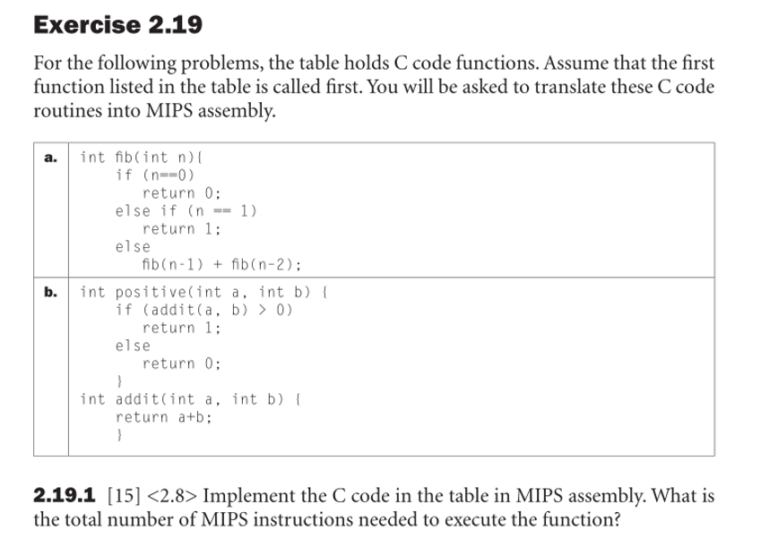
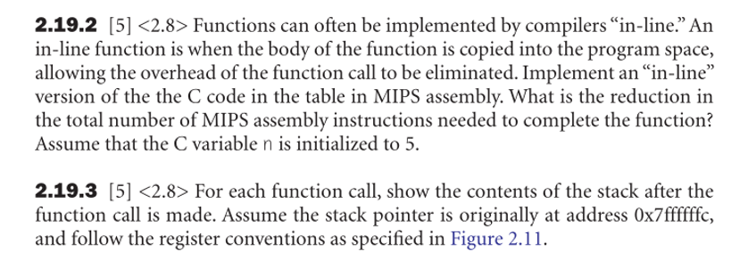
- Exercise 2.23.1
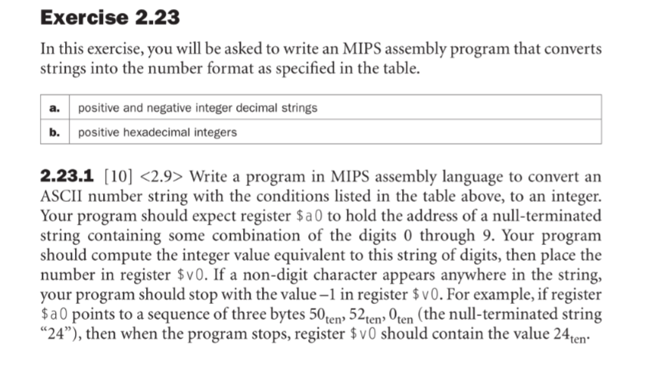
- Exercise 2.24.3
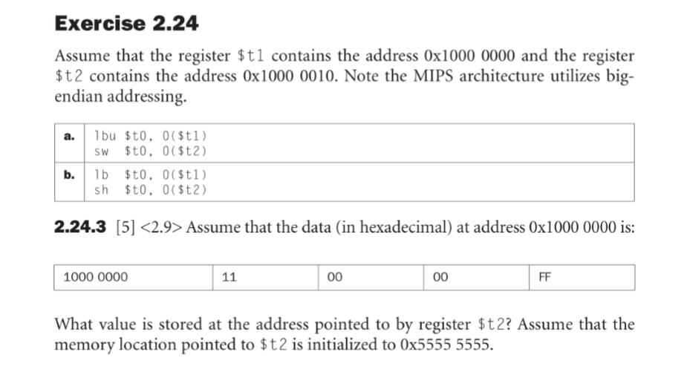
- Exercise 2.26.1
- Exercise 2.26.2
